Chapter 7, Solution 20.

- 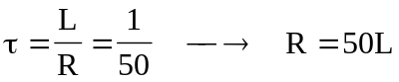
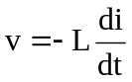
60 mH
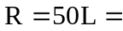 3 Ω
- 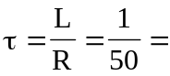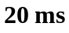
- 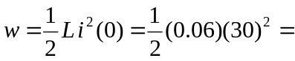 27 J
The value of the energy remaining at 10 ms is given by:
w₁₀ = 0.03(30e^{–0.5})² = 0.03(18.196)² = 9.933 J.
So, the fraction of the energy dissipated in the first 10 ms is given by:
(27–9.933)/27 = 0.6321 or 63.21%.

